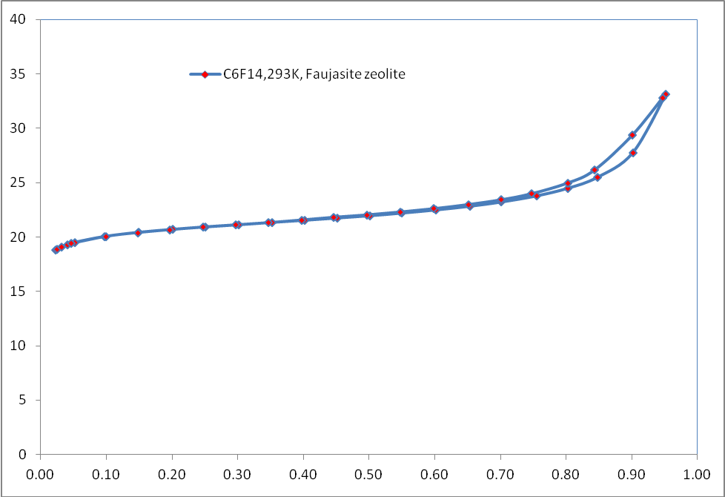

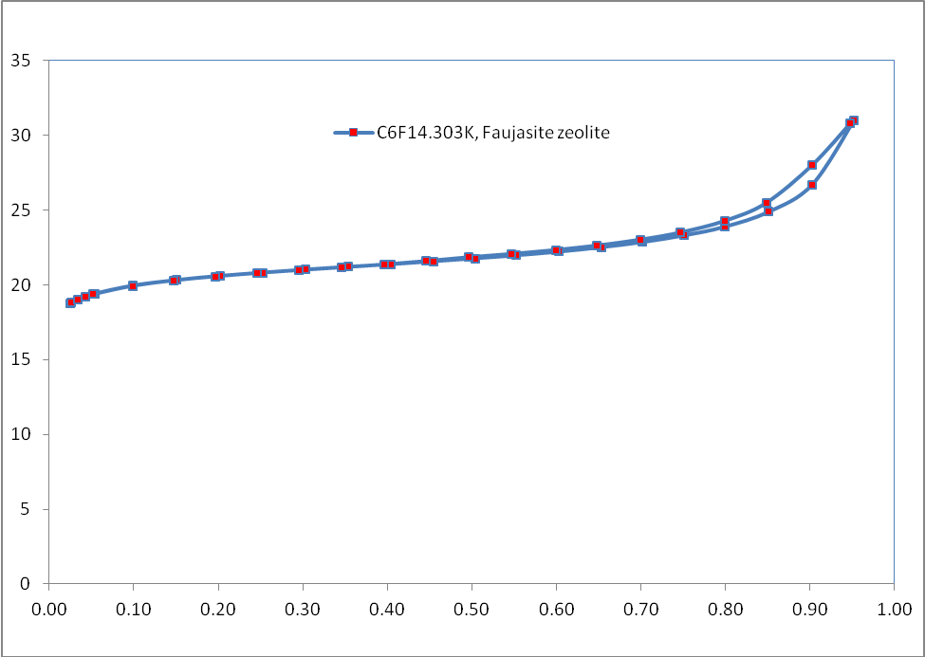

Comparison of Pore volumes (By Gurvitch Method)

P/Po | N2-77K | Ar-87K | C6F14-293K | C6F14-303K
0.8 | 0.2597 g/cc | 0.2288 g/cc | 0.2185 g/cc | 0.2130 g/cc

Note: The Gurvitch method applied at 0.2 relative pressures for C6F14 adsorption also provides the micro-pore volumes that are in good agreement with the argon and nitrogen adsorption data.

